St Barnabas’

Anglican Church

Friday 21ST June 6.00pm
MIDSUMMER BARBECUE
in the
Church Garden
Cooking by Chris Clapham & Friends

Bring and share salads and drinks

Fun Quiz and Raffle

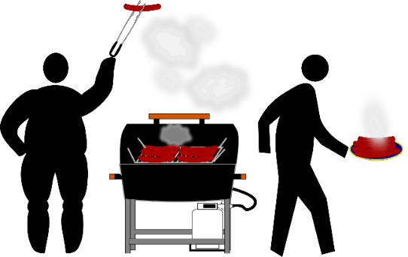
Tickets €5 from Christine Taylor
Everyone welcome

