St Barnabas’Day

Wednesday 12th June

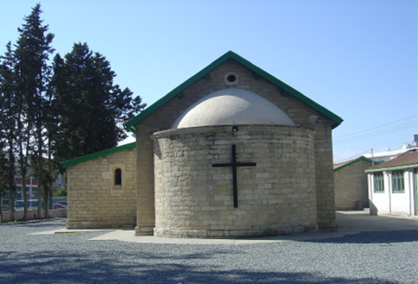

Come and join us for

Eucharist at 10.00am

followed by

coffee and cake in the Vicarage Garden

Everyone Welcome

