You are invited to the home of

**Anna Lewis**

**18 Archbishop Makarios Av 3rd, Kalavasos**

On Thursday 30th May

11.00 am – 1.00pm

tea/coffee, sandwiches and cake

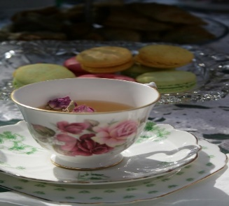

[This Photo](https://www.flickr.com/photos/sillypucci/5029572068) by Unknown Author is licensed under [CC BY-NC](https://creativecommons.org/licenses/by-nc/3.0/)

Books and cards for sale

Raffle

Friendship and Fun

**Proceeds to St Barnabas’ Church**

Do come along and support this event, if transport is a problem please speak to Anna or Christine Taylor and we’ll see if we can help.

Everyone welcome

Directions available from Anna

Tickets €5 from Anna or Christine